Poster preference study sheet and ‘Willingness to pay’ form
The research ethics approval has been obtained from the relevant Research Ethics Committee.
I am interested to find out what you would be willing to pay for certain kinds of posters, from a selection of examples.
You will find below images of 28 posters. From these, please choose three that you would select in physical form and three in digital (you can have the same poster in each). Please indicate the numbers of these as posters 1, 2 and 3 below. Then please mark the relevant boxes to indicate how much you would be willing to pay for each poster.
These might not be posters you would actually choose, but if you could select those closest to your reference, that would help to give me an idea of how much you would be willing to spend on what kind of image.
Price (£) | The Physical Posters you choose |  |  |  | The Digital Posters you choose
 | Poster [1] | Poster [2] | Poster [3] |  |  | Poster [4] | Poster [5] | Poster [6]
(a) £0 (Free) | ☐ | ☐ | ☐ |  |  | ☐ | ☐ | ☐
(b) £1 to £10 | ☐ | ☐ | ☐ |  |  | ☐ | ☐ | ☐
(c) £11 to £20 | ☐ | ☐ | ☐ |  |  | ☐ | ☐ | ☐
(d) £21 to £30 | ☐ | ☐ | ☐ |  |  | ☐ | ☐ | ☐
(f) £31 to £40 | ☐ | ☐ | ☐ |  |  | ☐ | ☐ | ☐
(g) £41 to £50 | ☐ | ☐ | ☐ |  |  | ☐ | ☐ | ☐
(h) £51 to £60 | ☐ | ☐ | ☐ |  |  | ☐ | ☐ | ☐
(i) £61 to £70 | ☐ | ☐ | ☐ |  |  | ☐ | ☐ | ☐
(j) £71 to £80 | ☐ | ☐ | ☐ |  |  | ☐ | ☐ | ☐
(k) £81 to £90 | ☐ | ☐ | ☐ |  |  | ☐ | ☐ | ☐
(l) £91 to £100 | ☐ | ☐ | ☐ |  |  | ☐ | ☐ | ☐
(m) £101 or more | ☐ | ☐ | ☐ |  |  | ☐ | ☐ | ☐

Example
Here is an example form for some of my own posters. Note that Poster 9 is the physical form of the digital poster 9.
Price (£) | The Physical Posters you choose |  |  |  | The Digital Posters you choose
 | Poster [1]  9 | Poster [2]  16 | Poster [3]  21 |  |  | Poster [4]  9 | Poster [5]  11 | Poster [6]  6
(a) £0 (Free) | ☐ | ☐ | ☐ |  |  | ☐ | ☐ | ☐
(b) £1 to £10 | ☐ | ☒ | ☐ |  |  | ☒ | ☒ | ☒
(c) £11 to £20 | ☐ | ☐ | ☐ |  |  | ☐ | ☐ | ☐
(d) £21 to £30 | ☒ | ☐ | ☐ |  |  | ☐ | ☐ | ☐
(f) £31 to £40 | ☐ | ☐ | ☐ |  |  | ☐ | ☐ | ☐
(g) £41 to £50 | ☐ | ☐ | ☒ |  |  | ☐ | ☐ | ☐
(h) £51 to £60 | ☐ | ☐ | ☐ |  |  | ☐ | ☐ | ☐
(i) £61 to £70 | ☐ | ☐ | ☐ |  |  | ☐ | ☐ | ☐
(j) £71 to £80 | ☐ | ☐ | ☐ |  |  | ☐ | ☐ | ☐
(k) £81 to £90 | ☐ | ☐ | ☐ |  |  | ☐ | ☐ | ☐
(l) £91 to £100 | ☐ | ☐ | ☐ |  |  | ☐ | ☐ | ☐
(m) £101 or more | ☐ | ☐ | ☐ |  |  | ☐ | ☐ | ☐

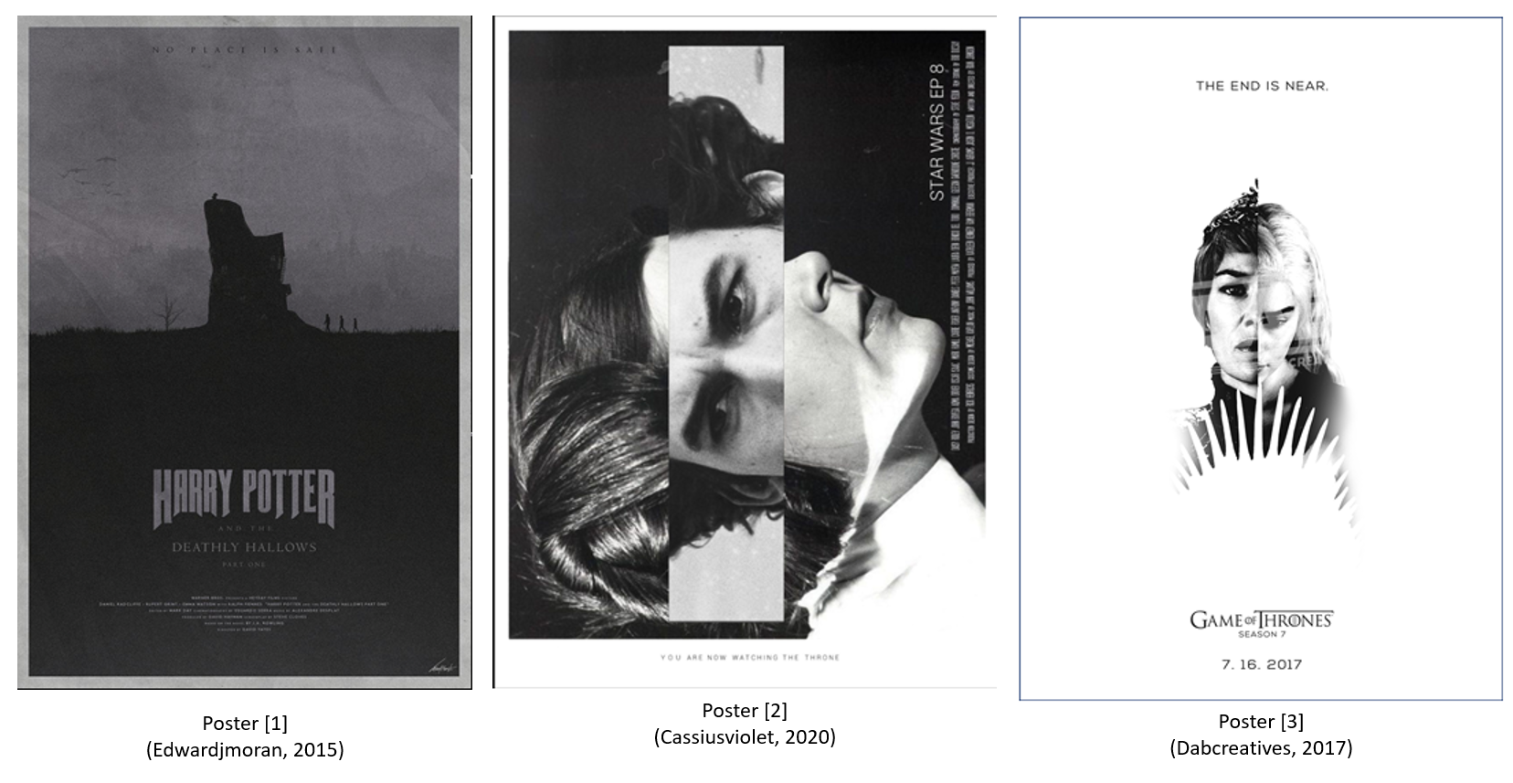
Science-Fiction and Fantasy Poster choices
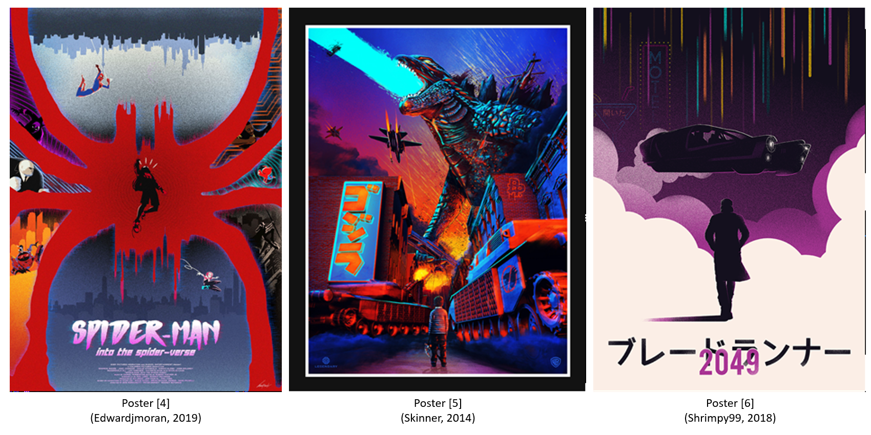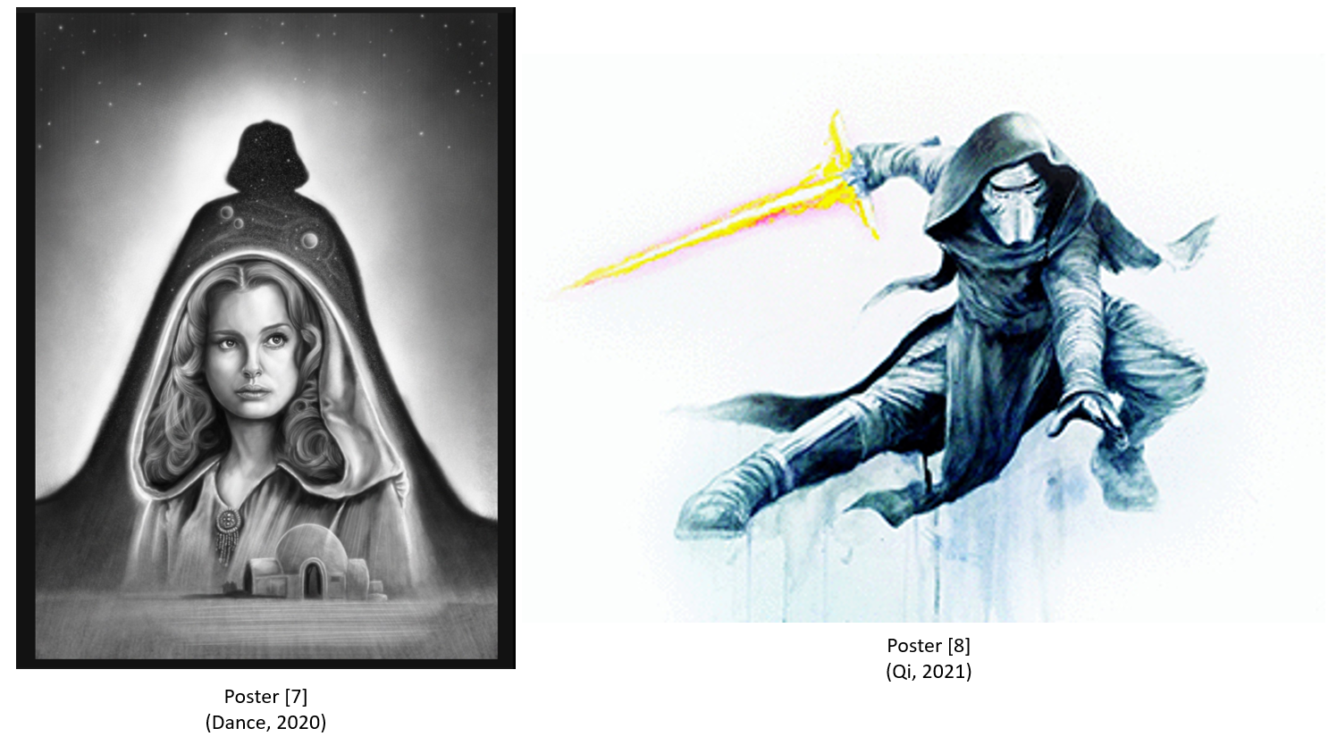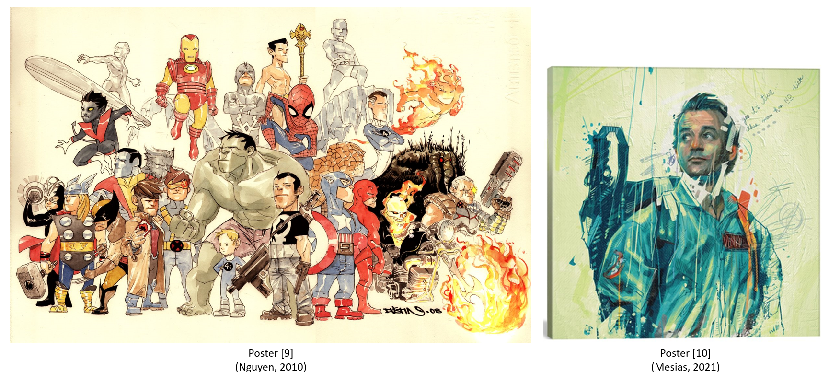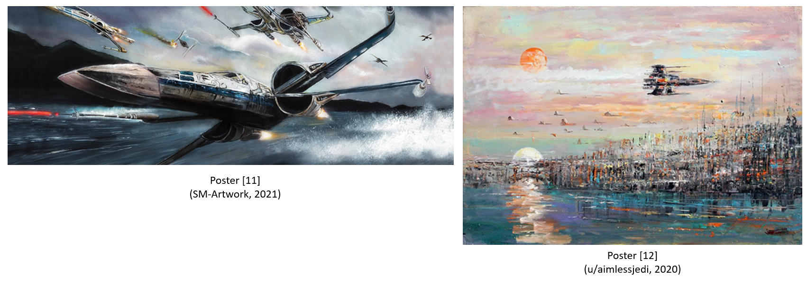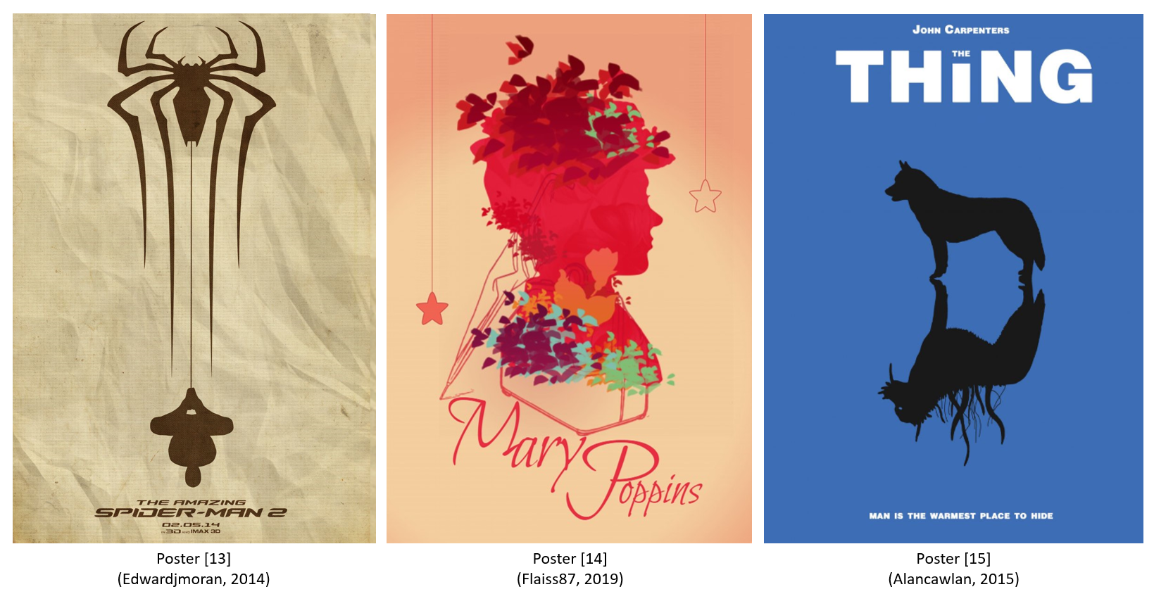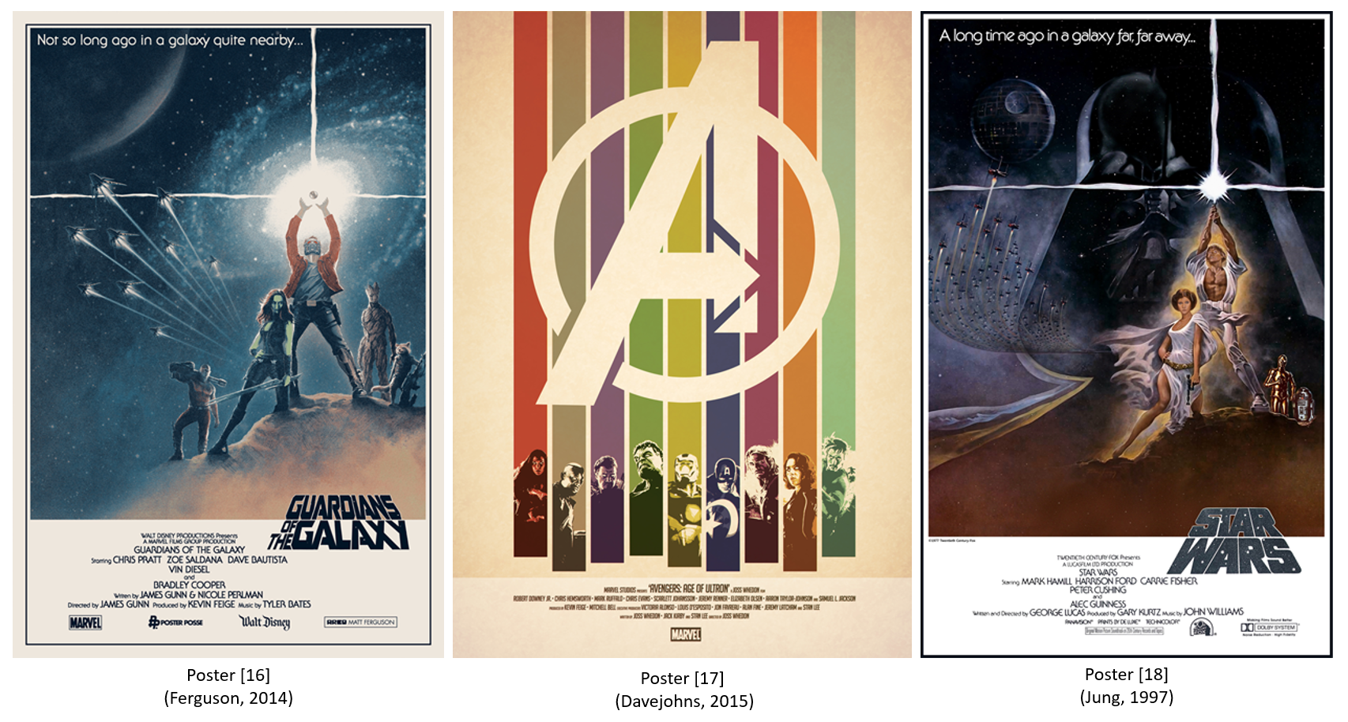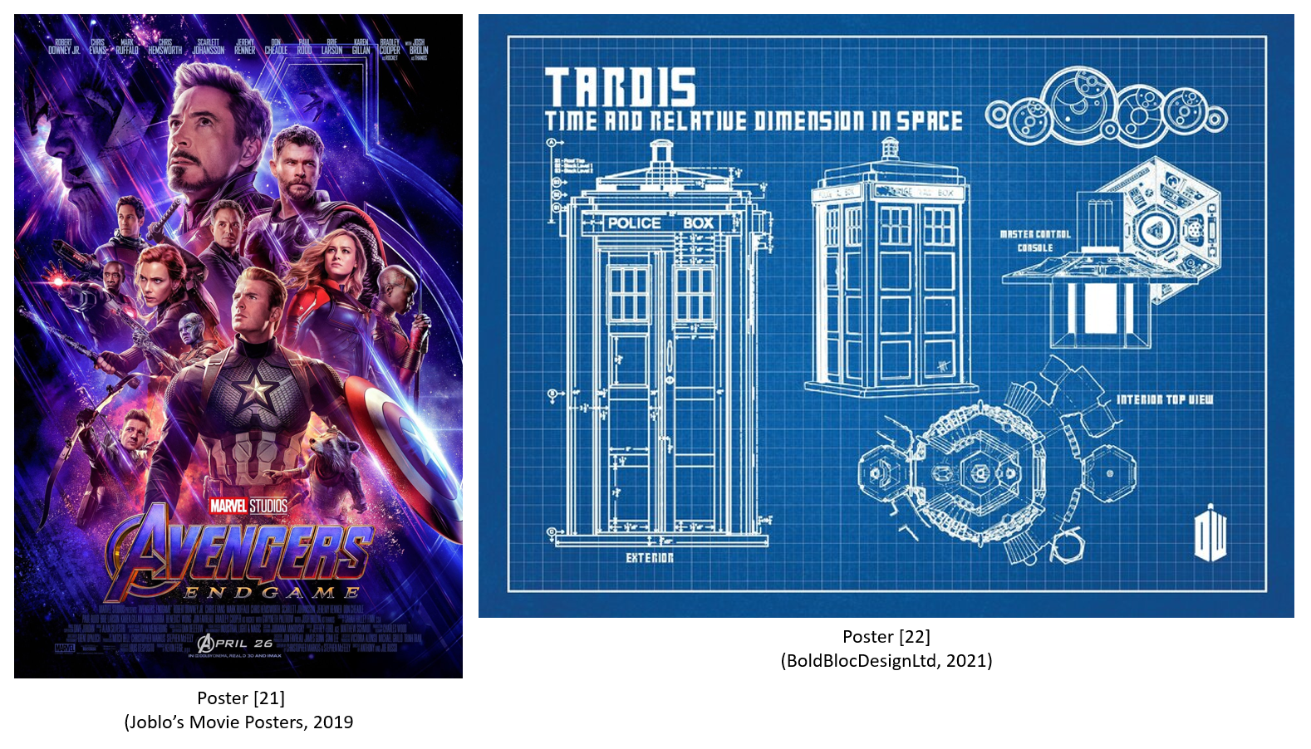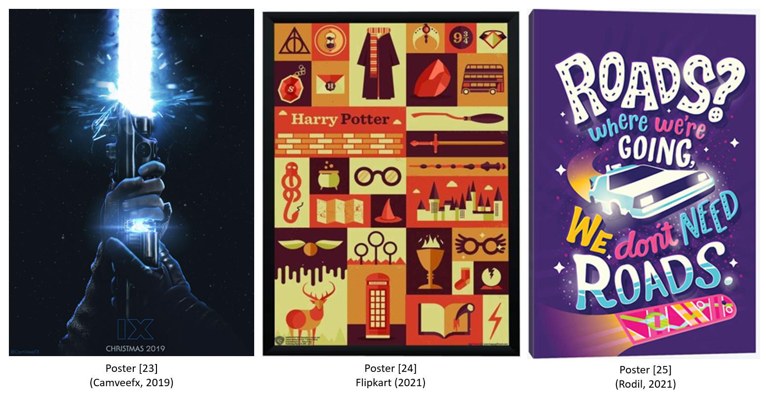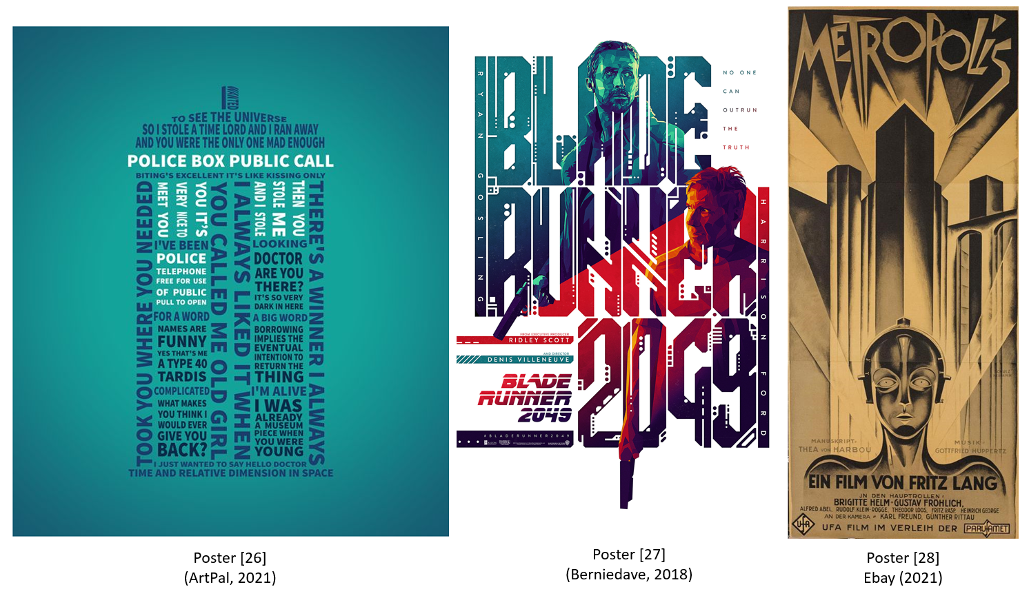

List of sources

Alancawlan, (2015) ‘The Thing’. Available at: https://posterspy.com/posters/the-thing-3/ [22.02.2021].

ArtPal (2021) ’ZoomRoom ViewShare TARDIS Typography’. Available at: https://www.artpal.com/inbarigami?i=18020-2 [22.02.2021].

Berniedave (2018) ‘Blade Runner 2049’. Available at: https://posterspy.com/posters/blade-runner-2049-24/ [22.02.2021].

BoldBlocDesignLtd (2021) ‘Dr Who Tardis Blueprints TV Show Television Movie Greats Canvas Art Print Box Framed Picture Wall Hanging’. Available at: https://www.etsy.com/uk/listing/704305736/dr-who-tardis-blueprints-tv-show?gpla=1&gao=1&&utm_source=google&utm_medium=cpc&utm_campaign=shopping_uk_en_gb_ds-b-Art_&_Collectibles-art_and_collectibles-other&utm_custom1=_k_CjwKCAiAyc2BBhAaEiwA44-wWzl5o-wxpKUxb5l7pnDC-aJ7qthn72kKed4zUnfU-47L9Nj_OIGgXBoCm2sQAvD_BwE_k_&utm_content=go_6479497888_86185562548_380845781443_pla-314954651973_c__704305736engb_140416642&utm_custom2=6479497888&gclid=CjwKCAiAyc2BBhAaEiwA44-wWzl5o-wxpKUxb5l7pnDC-aJ7qthn72kKed4zUnfU-47L9Nj_OIGgXBoCm2sQAvD_BwE [22.02.2021].

Camveefx (2019) ‘Star Wars Episode IX Teaser Poster’. Available at: https://posterspy.com/posters/star-wars-episode-ix-teaser-poster/ [22.02.2021].

Cassiusviolet (2020) ‘Star Wars, Mother and Son’. Available at: https://posterspy.com/posters/star-wars-mother-and-son/ [22.02.2021].

Dabcreatives (2017) ‘Game of Thrones Season 7 ‘The End is Near’’. Available at: https://posterspy.com/posters/game-of-thrones-season-7-the-end-is-near/ [22.02.2021].

Dance, W. (2020) ‘Padmé Amidala’. Available at: https://posterspy.com/posters/padme-amidala-2/ [22.02.2021].

Davejohns (2015) ‘Vintage of Ultron’. Available at: https://posterspy.com/posters/vintage-of-ultron/ [22.02.2021].

Ebay (2021) ‘Metropolis 1927 Fritz Lang Vintage 3 Sheet Movie Poster Fine Art Lithograph S2’. Available at: https://www.ebay.co.uk/itm/203143934851?chn=ps&norover=1&mkevt=1&mkrid=710-134428-41853-0&mkcid=2&itemid=203143934851&targetid=878692190845&device=c&mktype=pla&googleloc=9045941&poi=&campaignid=9437781752&mkgroupid=95524282733&rlsatarget=pla-878692190845&abcId=578896&merchantid=101761437&gclid=Cj0KCQiA1pyCBhCtARIsAHaY_5fe4AkiDy12fxyBYSS9AWfbBZ9Jxa8oN2nvuZGywRY2B2LyraXCZIkaAk-DEALw_wcB [22.02.2021].

Edwardjmoran (2015) ‘Harry Potter and the Deathly Hallows Pt 1 – Poster’. Available at: https://www.deviantart.com/edwardjmoran/art/Harry-Potter-and-the-Deathly-Hallows-Pt-1-Poster-564544782 [22.02.2021].

Edwardjmoran (2014) ‘The Amazing Spiderman 2 - Poster’. Available at: https://www.deviantart.com/edwardjmoran/art/The-Amazing-Spiderman-2-Poster-444705549 [22.02.2021].

Edwardjmoran (2019) ‘It Always Fits - Spider-Man: Into The Spider-Verse’. Available at: https://www.deviantart.com/edwardjmoran/art/It-Always-Fits-Spider-Man-Into-The-Spider-Verse-784183955 [22.02.2021].

Ferguson, M. (2021) ‘Solo: A Star Wars Story’. Available at: https://www.cakesandcomics.com/#/solo-a-star-wars-story/ [22.02.2021].

Ferguson, M. (2014) ‘Guardians Of The Star Wars Galaxy’. Available at: https://posterspy.com/posters/guardians-of-the-star-wars-galaxy/ [22.02.2021].

Flaiss87 (2019) ‘Mary Poppins’. Available at: https://posterspy.com/posters/mary-poppins-3/ [22.02.2021].

Flipkart (2021) ‘WB Official Licensed Harry Potter Icon Art Typography Poster A4 Frame Paper Print (11.7 inch X 8.3 inch, Rolled)’. Available at: https://www.flipkart.com/wb-official-licensed-harry-potter-icon-art-typography-poster-a4-frame-paper-print/p/itmf9es3nvg7ugdf?pid=POSF9EYEEG5KBZSE&lid=LSTPOSF9EYEEG5KBZSEHCA46B&marketplace=FLIPKART&srno=b_37_1478&otracker=browse&fm=organic&iid=721ed423-65a7-4f82-96bb-ea0c724b0676.POSF9EYEEG5KBZSE.SEARCH&ssid=uqr8w53e6o0000001568844666004 [22.02.2021].

Joblo’s Movie Posters (2019) ‘Avengers: Endgame Poster (#49 of 50)’. Available at: https://www.joblo.com/movie-posters/2019/avengers-endgame/image-35164 [22.02.2021].

Jung, T. (1997) ‘Tom Jung’. Available at: https://starwars.fandom.com/wiki/Tom_Jung [22.02.2021].

Mesias, A. (2021) ’Ghostbusters - Canvas Print’. Available at: https://www.icanvas.com/canvas-print/ghostbusters-ame2#1PC6-26x26 [22.02.2021].
Nguyen, D. (2010) ‘Marvel Heroes Print by Dustin Nguyen’. Available at: https://www.comicartfans.com/gallerypiece.asp?piece=611865 [22.02.2021].

Qi, Q. (2021) ‘009 Kylo Ren’. Available at: https://guizang.co.uk/epages/7c4de348-fdb6-4222-81f3-aade5a67fbbd.mobile/en_GB/?ObjectPath=/Shops/7c4de348-fdb6-4222-81f3-aade5a67fbbd/Products/009 [22.02.2021].

Rjartworks (2019) ‘Fantastic Beasts: The Crimes of Grindelwald’. Available at: https://posterspy.com/posters/fantastic-beasts-the-crimes-of-grindelwald-5/ [22.02.2021].

Rodil, R. (2021) ’Back To The Future - Canvas Print’. Available at: https://www.icanvas.com/canvas-print/back-to-the-future-rro5#1PC6-40x26 [22.02.2021].

Shrimpy99 (2018) ‘Blade Runner 2049’. Available at: https://posterspy.com/posters/blade-runner-2049-39/ [22.02.2021].

Skinner (2014) ‘GODZILLA!’. Available at: https://posterspy.com/posters/godzilla-4/ [22.02.2021].

SM-Artwork (2021) ‘SM-Artwork’. Available at: https://www.sm-artworks.co.uk/ [22.02.2021].

u/aimlessjedi (2020) ‘Star Wars themed landscape painting by me’. Available at: https://www.reddit.com/r/pics/comments/brcje2/star_wars_themed_landscape_painting_by_me/ [22.02.2021].

